# [Franchising your mailbox might put the USPS out of business](https://www.freightwaves.com/news/franchising-your-mailbox-might-put-the-usps-out-of-business" \t "_blank)

[February 11, 2019](https://www.freightwaves.com/news/franchising-your-mailbox-might-put-the-usps-out-of-business) [Vishnu Rajamanickam, staff writer](https://www.freightwaves.com/news/?author=59b88906f43b55a58488f224)

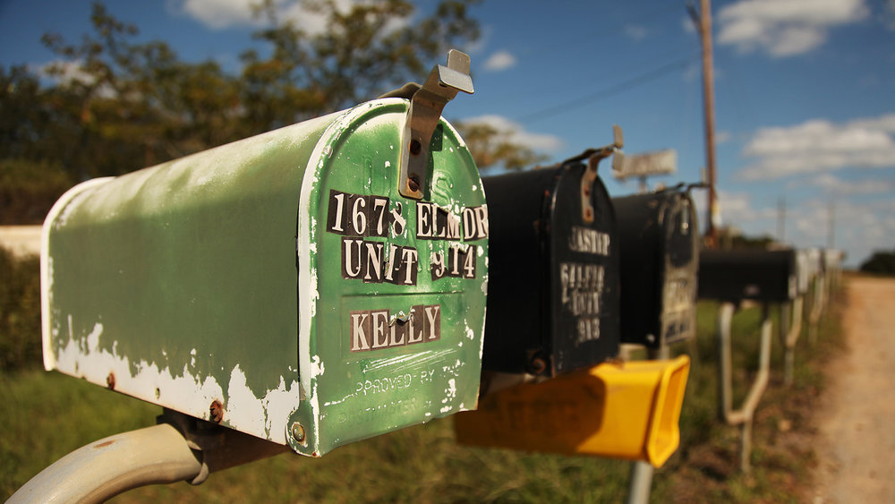

PHOTO: FLICKR/ALEXWEIMER

LinkedInFacebookTwitterEmailDiggReddit

As far as the current regulations go, only you and the U.S. Postal Service (USPS) have the authority to put mail or parcels in your mailbox. Anyone who infringes on this is quite literally committing a crime – even if it is a neighbor who is putting remainder notes into your box. The law might sound bizarre, but it goes back many years and is one of the final frontiers protecting the USPS from cascading into chaos.

Going back to the Great Depression, the Congress enacted a law that prohibited anyone but the USPS and the said customer from handling the mailbox. The law incidentally was meant to stop people from circumventing the postal service by putting mail directly into mailboxes without the buying postage stamps. Though the mailbox monopoly has been challenged multiple times, neither the government nor the [Supreme Court has shown any inclination in amending it](https://supreme.justia.com/cases/federal/us/453/114/).

Nonetheless, the debate over the mailbox monopoly is far from over. A White House task force stated last December about the [need for USPS to explore the option of franchising the mailbox](https://www.freightwaves.com/news/parcel/postal-task-force-gives-ups-gift) to prop up its declining margins. The USPS has indeed seen some of its worst years this decade, with 2018 generating a [$3.9 billion loss](https://www.govexec.com/management/2018/11/postal-service-loses-39-billion-fiscal-2018/152826/)  – a 44 percent increase in losses compared to the previous year.

In the age of digitization, the relevance of snail mail continues to decline, and it is crucial for the USPS to look for ways it can continue to survive, especially against the onslaught of logistics majors like FedEx, UPS and DHL.

USPS increased the cost of first-class stamp prices by five cents recently. Though this could help boost revenue in the short-term, the USPS must come to terms with the fact that people are sending letters and bill payments less frequently, with first-class mail volume dropping by 2.1 billion pieces in 2018.

However, franchising the mailbox might turn out to be an idea that could eventually come back to haunt USPS. Providing companies like FedEx or UPS the leverage to access personal mailboxes would allow them to deliver faster than before, as couriers would no longer need to get to the door and wait for the customer to sign for every parcel. USPS, which already has a problem keeping up with the pace of private logistics players, would be left in the lurch as regular USPS customers might also move to faster private players.

The real issue though, is with the people who live in rural or hard to reach locations, like the remotest parts of Alaska for instance. Many villages there hardly account for a couple of hundred people and delivering to such locations would need logistics services to charter flights to hand over a few parcels. Being a quasi-government monopoly, the USPS does this, as it is obligated to serve the interests of every single U.S. citizen.

When faced with such a scenario, most of the private players would possibly refuse to deliver to rural and sparsely populated areas because it would hit their bottom lines, with the exorbitant delivery costs not measuring up to the revenue they can generate. If the mailboxes do get franchised and the fate of the USPS is further endangered, we might need to contend with a reality where some people might lose their only connection to the outside world.

The essence of the U.S. Postal Service is not in its efficiency, but rather in its widespread connectivity and the extent to which it goes to provide mail service for every person in the country. Asking that of the private logistics players is inane, as they exist to make money for their shareholders and to deploy their infrastructure in places where they cannot show a profit is not an exercise worth their time. In fact, most of the private players pay the USPS to haul their parcels to the remote locations rather than doing it themselves.

Instead of mulling over franchising mailboxes, it might serve the USPS better if it looks to expand its financial services like money orders, international money transfers and bill payments. As an organization that people trust, such actions might prove beneficial to the institution.

Congress could also look to amend the Postal Accountability and Enhancement Act (PAEA) of 2006, which requires the USPS to [pre-fund its retiree healthcare benefits](https://www.cnbc.com/id/45018432). This necessitates the USPS to save up money over the course of an employee’s career and provide him/her with full benefits at retirement. Though this does sound promising, members of the postal workers union believe that this has created a fiscal problem, as the law warrants the USPS to fund retirement obligations of potential future employees  – not a favorable position to be in for a cash-strapped institution.

To undo the financial mess the USPS finds itself in, the Trump administration should take concrete steps to solve such issues and increase revenue by expanding on financial services. That said, it certainly must not blame Amazon for USPS’ woes  – as on the contrary, companies like Amazon accounted for $7 billion out of USPS' $19.5 billion parcel revenue. Amazon [ships 40 percent of its packages](https://www.politifact.com/truth-o-meter/statements/2018/apr/02/donald-trump/trump-usps-postal-service-amazon-losing-fortune/) in the U.S. through USPS, and as the PAEA act makes it illegal for USPS to price parcel delivery below its cost, its deal with Amazon is at least breaking-even if not turning in a profit.

Thank You

Tony Dallojacono

Tony Dallojacono

NAPS Mideast Area VP

*Work : 732-363-1273*

*Cell: 973-986-6402*