# MSPB Seeks Funding Boost, Contrary to Administration Request

*Published:*[*March 26, 2019*](https://www.fedweek.com/fedweek/mspb-seeks-funding-boost-contrary-to-administration-request/)

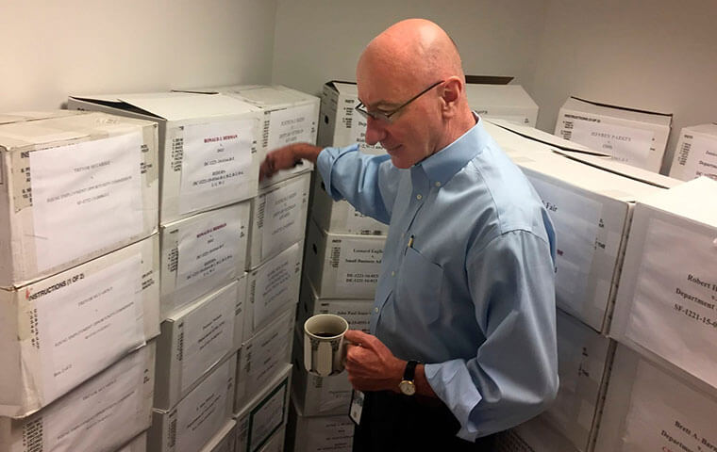Washington DC, Aug. 7 2018 - Mark Robbins was the last member of the Merit Systems Protection Board until his departure in February. Robbins read through federal workplace disputes, analyzed cases, marked them with notes and logged legal opinions. He then passed them along to nobody since the board couldn't legally operate without at least two members.

In an unusual move, the MSPB has submitted a “bypass request” to Congress, saying that the White House’s fiscal 2020 budget request for it would be inadequate, asking for $46.8 million, about $4.6 million above the Trump administration’s request.

The higher figure “accurately reflects MSPB’s funding needs to address operational and management priorities ranging from personnel to modernizing our information technology,” the MSPB said in a budget justification document. Enacting the White House-proposed figure, it said, would require eliminating jobs, slow the processing of employee appeals in disciplinary cases, and hamper other activities such as conducting surveys and studies on federal personnel issues.

The MSPB also pointed to a heavy workload facing it. The agency currently has no seated members on its three-member board, and since January 2017 has lacked the quorum needed to decide on appeals of hearing officer decisions. At that time there were 528 such appeals pending and now there are 2,041, it said.

In addition to tackling that backlog, the board said it expects an increase in its workload as the effects are felt of:

* a 2016 law that created an appeal right in certain situations when an employee is put on pending an agency investigation that might lead to discipline;  
* a 2017 law giving employees greater rights to contest a personnel action based on refusal to follow an order that the employee believes would require violating a law, rule or regulation;  
* a 2017 law that extended whistleblower protections and that requires agency heads to propose disciplinary action against supervisors who are found to have engaged in retaliation;  
* a 2018 law that extended protections for employees who cooperate with internal agency investigations; and  
* a 2018 executive order that it said will have the effect of discouraging settlements in personnel disputes by barring agencies from agreeing to erase charges from an employee’s record as part of a settlement.