# UPS just beat out Amazon, FedEx, and Uber to make America's first revenue-generating drone delivery

[Rachel Premack](https://www.businessinsider.com/author/rachel-premack)

Mar. 26, 2019, 12:30 PM

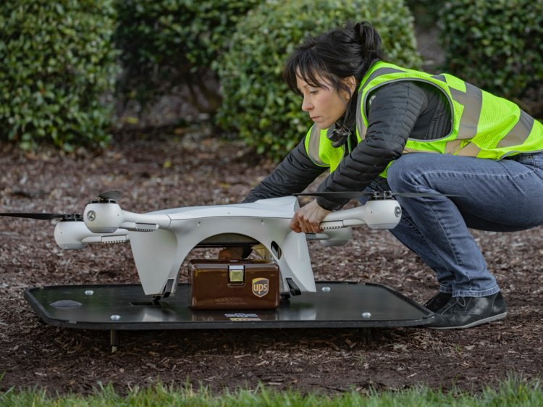UPS just started America's first drone delivery route. Courtesy of Ryan Davis/UPS

•         [UPS](https://www.businessinsider.com/category/ups), in partnership with the drone technology company [Matternet](https://www.businessinsider.com/category/matternet), on Tuesday began its daily [drone delivery](https://www.businessinsider.com/category/drone-delivery) of medical supplies in WakeMed's campus in Raleigh, North Carolina.

•         The [drone](https://www.businessinsider.com/category/drone) delivery cut the transport time of crucial medical samples from about half an hour to just over three minutes.

•         It is the first revenue-generating drone delivery in the US, Bala Ganesh, the vice president of the Advanced Technology Group at UPS, told Business Insider.

•         UPS is part of a public-private US Department of Transportation drone-testing program started last spring. [Amazon](https://www.businessinsider.com/category/amazon), which has made highly publicized moves into drone testing, [was not included](https://thehill.com/policy/technology/387034-faa-announces-tests-on-autonomous-drone-deployment) in the program.

Moving medical samples around WakeMed's sprawling medical campus in Raleigh, North Carolina, can sometimes take up to 30 minutes in traffic. That can be challenging when the material being moved is a life-saving specimen like blood or an organ sample.

But drone delivery has cut that commute to three minutes and 15 seconds.

UPS, in collaboration with the drone technology company Matternet, made its first revenue-generating delivery of medical samples at WakeMed Raleigh on Tuesday. The Federal Aviation Administration and the North Carolina Department of Transportation provided oversight.

It's a major step for proving the worthiness of the highly regulated and much-hyped technology.

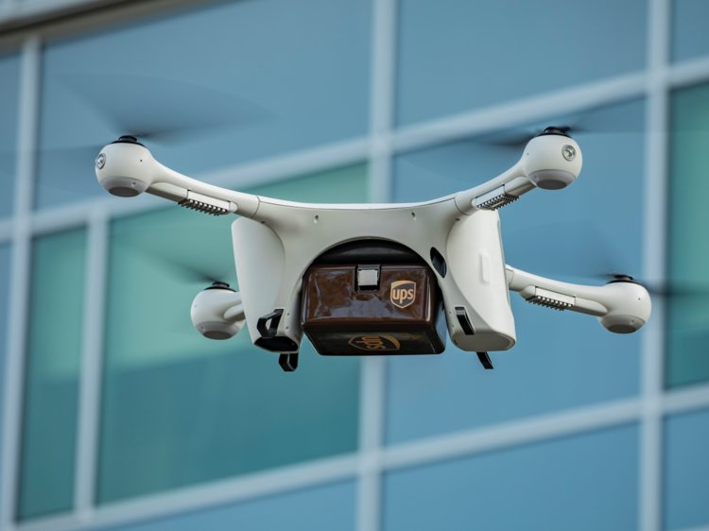A UPS drone. Courtesy of Ryan Davis/UPS

"This particular use case of healthcare specimens within the healthcare campus is not only critical in a just-in-time event, but it could be a life-changing event," Bala Ganesh, the vice president of the Advanced Technology Group at UPS, told Business Insider. "The capabilities we bring to the table adds on to the capabilities for healthcare to provide better service and patient care to their patients."

## The drone's first revenue-generating route

It was the first revenue-generating drone delivery in the US — "not a demo or a test," Ganesh said.

UPS is set to make fewer than 10 drone deliveries a day around WakeMed, but it could scale up.

**Read more:**[UPS CEO David Abney reveals why the logistics giant hasn't pushed into one of delivery's fastest-growing sectors](https://www.businessinsider.com/ups-ceo-furniture-delivery-2019-1)

Companies ranging from [Domino's](https://qz.com/838254/dominos-is-delivering-pizza-with-autonomous-drones-to-customers-in-new-zealand/) to [Amazon](https://www.amazon.com/Amazon-Prime-Air/b?ie=UTF8&node=8037720011&tag=bisafetynet2-20) have made highly publicized pushes into drone delivery. But none has managed to establish a regular, revenue-generating business from the drones.

The sluggishness in drone technology is due partially to government regulation. [The BBC reported in December](https://www.bbc.com/news/business-46483178) that governments worldwide were worried about the potential for "rogue drone use" and the safety concerns that could stem from drones malfunctioning and falling from the sky.

But last May, the Department of Transportation [took a major step](https://www.bloomberg.com/news/articles/2018-05-09/drone-tests-from-deliveries-to-farming-unveiled-by-government) in better regulating the commercial use of drones, announcing that 10 state, local, and tribal governments were approved to work with private corporations to test drone technology. The North Carolina Department of Transportation, working with UPS and Matternet, [is one of the participants](https://www.faa.gov/uas/programs_partnerships/integration_pilot_program/), though UPS's involvement in the program was [previously undisclosed](https://www.npr.org/sections/health-shots/2018/03/10/592059175/medical-cargo-could-be-the-gateway-for-routine-drone-deliveries).

Uber, FedEx, Intel, and Qualcomm, as well as startups like Airmap and Flirtey, are other known participants. Amazon was [not selected](https://thehill.com/policy/technology/387034-faa-announces-tests-on-autonomous-drone-deployment) for the program.

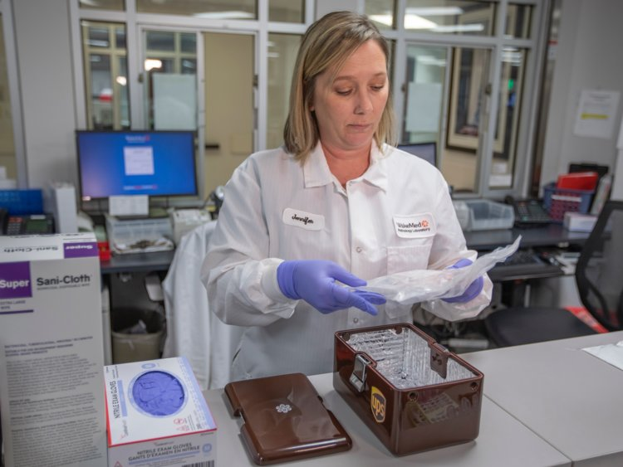A WakeMed doctor with UPS-delivered samples. Courtesy of Ryan Davis/UPS

Companies and governments in the program are focusing on areas like aircraft and airport runway inspections, drone landing stations and ports, and deliveries.

Ganesh said UPS, which already has a [robust medical-supply-chain network](https://www.ups.com/us/en/services/healthcare/supply-chain-management.page), was chiefly interested in the healthcare applications of drones. In 2016, UPS Foundation partnered with Gavi, a health organization, and Zipline, a drone company, as part of an effort to [deliver blood transfusions to remote areas in Rwanda](https://pressroom.ups.com/pressroom/ContentDetailsViewer.page?ConceptType=PressReleases&id=1462760058735-442).

[Experts have said](https://www.npr.org/sections/health-shots/2018/03/10/592059175/medical-cargo-could-be-the-gateway-for-routine-drone-deliveries) the [nearly $10 trillion global healthcare industry](https://www2.deloitte.com/content/dam/Deloitte/global/Images/infographics/lifesciences-healthcare/gx-lshc-hc-outlook-2019-infographic.pdf) could be seriously bolstered by drone delivery technology, particularly in disaster zones or remote areas.

"Our focus is on healthcare, just-in-time, real urgent movements, life-changing events in hard-to-reach locations," Ganesh said. "That's our primary focus because that's where we believe there's a new market, a new innovative use case that has not been satisfied today."