# Stamps.com: A Broken Stock And A Broken Business

Mar. 27, 2019 2:24 PM ET

|

 About: [Stamps.com Inc. (STMP)](https://seekingalpha.com/symbol/STMP)

**Summary**

Stamps.com's recent price drop may look like a buy-the-dip opportunity to a value investor if it is a case of market overreaction to a short term event.

Unfortunately, upon looking deeper, it appears that Stamps.com has broken fundamentals that make it a vulnerable business with a poor growth prospect.

With a revenue concentration risk, a disrupted business model, a potential conflict of interest, and questionable management behaviors, Stamps.com is a shaky business.

Long investors should stay away from it because it is unlikely a quick turnaround story, while short investors may have further gains as more bad news is expected in the near future.

The share price of Stamps.com ([STMP](https://seekingalpha.com/symbol/STMP)) dropped like a rock after its announcement of ending its exclusive shipping partnership with USPS, United States Postal Service, in order to pursue other private carriers. Stamps.com CEO Ken McBride claimed that the shifting market environment of the shipping and logistics industry was the main driver for the decision to break away from USPS, which, in McBride's prediction, would become less and less competitive in facing powerful new entrants like Amazon ([AMZN](https://seekingalpha.com/symbol/AMZN)). In doing so, Stamps.com guided its revenue down by 5% and halved its earnings guidance in 2019.

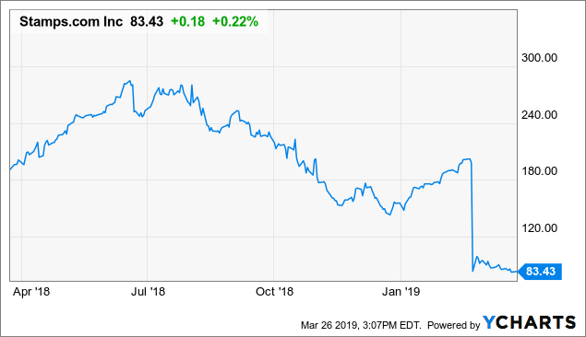Data by YCharts

The immediate negative reaction from the market is understandable. However, could such a drastic strategic shift be justifiable for the sake of its long-term prospect? Could this be a great buy-the-dip opportunity for a value-oriented investor because it might be a simple case of market overreaction to a short-term event? After all, Stamps.com has been an impressive growth company for the last few years. Unfortunately, this may not be a case of a quick rebound. Instead, it is likely a slow spiral down toward a smaller existence, if not irrelevance.