# Postal Service reissues Policy on Workplace Harassment

*March 28, 2019* —

Effective March 14, 2019, the Postal Service™ reissued its Memorandum of Policy (MOP) HR-03-14-2019-2, [***Postal Service Policy on Workplace Harassment***](https://about.usps.com/postal-bulletin/2019/pb22516/html/info_003.htm#ep1462579).

This policy:

n Reaffirms the Postal Service’s commitment to providing a work environment free of harassment.

n Reflects the replacement of the Centralized Intake System for initiating requests for Equal Employment Opportunity (EEO) counseling with the online efile application. The revision describes the primary and alternative process to initiate EEO counseling on the online EEO efile application.

n Supersedes MOP HR-03-16-2017-2, Postal Service Policy on Workplace Harassment.

The reissued Postal Service Policy on Workplace Harassment is available on the Postal Service PolicyNet website:

n Go to [**blue.usps.gov**](http://blue.usps.gov/).

n In the left-hand column under “Essential Links,” click PolicyNet.

n Go to the right-hand side under “Published Forms and Directives.”

n Click Memorandums of Policy.

The direct URL for the Postal Service PolicyNet website is [**blue.usps.gov/cpim**](http://blue.usps.gov/cpim).

**[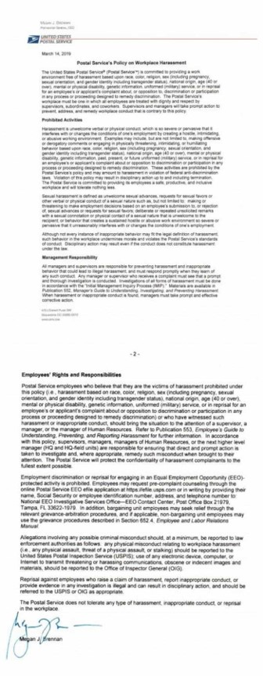](https://www.postaltimes.com/wp-content/uploads/2019/03/info_003_1-down.jpg)**