# Postal Service reissues Equal Employment Opportunity Policy Statement

*March 28, 2019* —

Effective March 14, 2019, the Postal Service™ reissued its Memorandum of Policy (MOP) HR-03-14-2019-1, [***Equal Employment Opportunity Policy Statement***](https://about.usps.com/postal-bulletin/2019/pb22516/html/info_002.htm#ep1463206) .

In accordance with the Equal Employment Opportunity Commission’s Management Directive 715, the policy will be updated annually and prominently posted in the following locations:

n All personnel offices;

n Equal Employment Opportunity (EEO) offices;

n On the agency’s internal website; and

n Throughout the workplace.

This policy reaffirms the Postal Service’s commitment to equality of opportunity in every aspect of employment and supersedes MOP HR-03-29-2018.

The reissued Equal Employment Opportunity Policy Statement is available on the Postal Service PolicyNet website:

n Go to [**blue.usps.gov**](http://blue.usps.gov/).

n In the left-hand column under “Essential Links,” click PolicyNet.

n Go to the right-hand side under “Published Forms and Directives.”

n Click Memorandums of Policy.

The direct URL for the Postal Service PolicyNet website is [**blue.usps.gov/cpim**](http://blue.usps.gov/cpim).

**[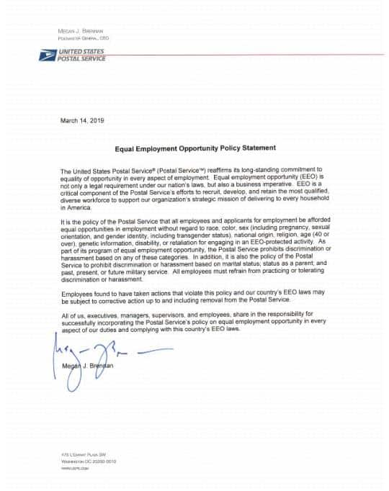](https://www.postaltimes.com/wp-content/uploads/2019/03/info_002_1.jpg)**