# The Pony Express service began on April 3rd in 1860

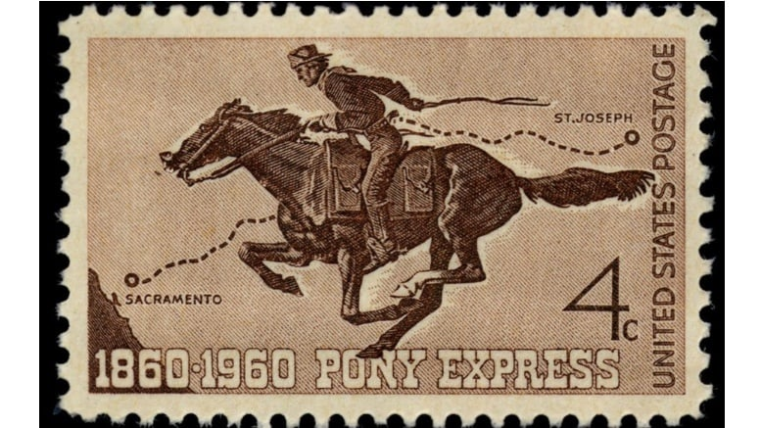

The [#PonyExpress](https://twitter.com/hashtag/PonyExpress?src=hash) service began [#OTD](https://twitter.com/hashtag/OTD?src=hash) in 1860. Customers paid $10 per ounce for the 10 day express between San Francisco, CA, & St. Joseph, MO. That's over $300 an ounce according to current-day inflation! Check out "Pony Express: Romance vs. Reality" [http://ow.ly/g9YM30ofDZS](https://t.co/R5LpJFrheE)