# Consolidated Casing being tested for City Carriers

*April 22, 2019* — Over 230 post offices nationwide will be test sites for this process. Phase 1 will be in May, Phase 2 in June, and Phase 3 in August.

Under this test, carriers will either be “casing multiple routes” or “delivering on the street for 7 hours and 45 minutes”.

**[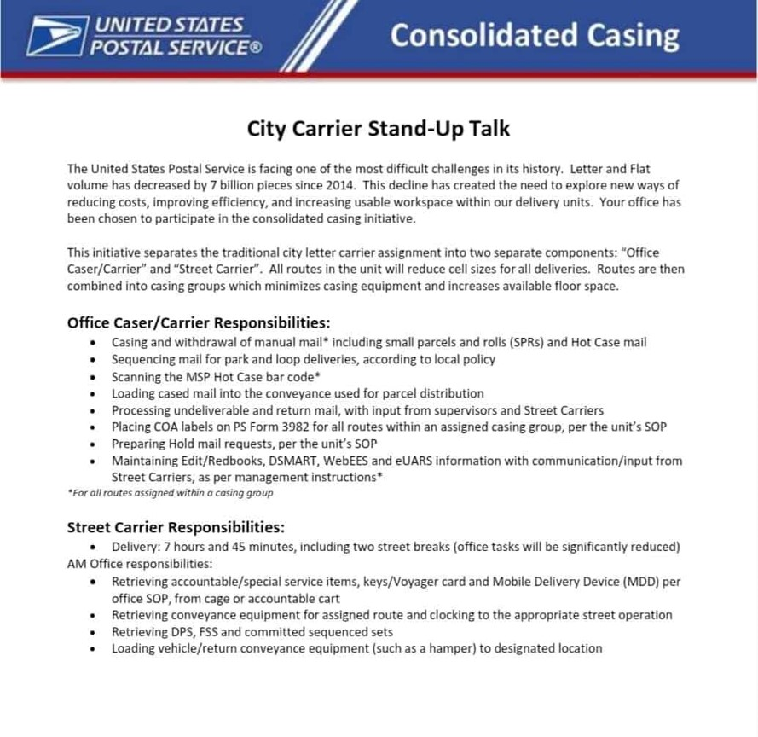](https://www.postaltimes.com/wp-content/uploads/2019/04/57456814_1152654304916877_5228676418598076416_o.jpg)**